Appendix 2.

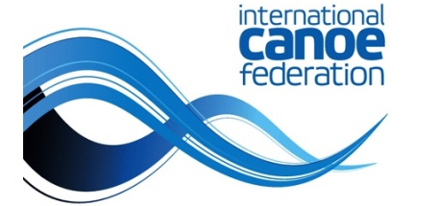
2021 ICF CANOE SPRINT AND PARACANOE WORLD CUP
14 – 16 May 2021 | Szeged HUNGARY

CREW CHANGE

NATION

Race Number | Date | Time | Event | Heat |  | Final
COMPETITOR(S) REPLACED BY…
No | Name |  | No | Name
Any athlete named in the final entry of his/her country may substitute in any other event.
Notification of alterations of the entries must be given in written form to the Chief Official at least one (1) hour before the first race of the morning or afternoon session.
The withdrawal of an entry is considered final and the same athlete/crew is not allowed to compete in any other events of the competition.
In crew boats the names of the competitors must be in order that they race in the boat. The first name at the top must be the competitor at the front of the boat.
RECIEVED | DATE | TIME

TEAM LEADER’S SIGNATURE & NAME |  |  | CHIEF OFFICIAL’S SIGNATURE & NAME

* This competition form MUST be received by Chief Official at 15:00 on Tuesday,
11th May 2021. the latest.

